Expno:10ImplementBoundaryconditionbetweentwodifferentdielectricmediumin MagneticFieldandfindtherelativepermeabilityofthedifferentmedium.
Aim:TowriteprogramforBoundaryconditionbetweentwodifferentdielectricmediain magnetic field using SCILAB.
Softwarerequired:•SCILABversion6.0.1
Theory:Whenamagneticfieldispresentattheboundarybetweentwodifferent dielectricmedia(ormagneticmaterials),boundaryconditionsgovernhowthemagnetic fieldbehavesasitcrossesfromonemediumtotheother.Theseboundaryconditions arisefromMaxwell'sequationsandthepropertiesofthematerialsinvolved,suchas relativepermeability,μr,whichgovernsthematerial'sresponsetothemagneticfield.
Coding:
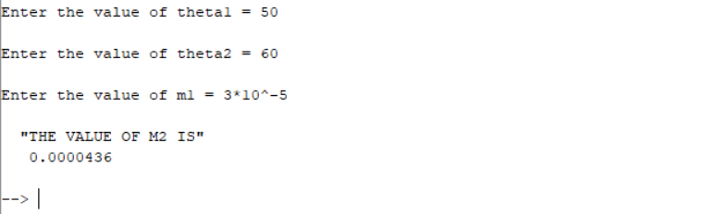
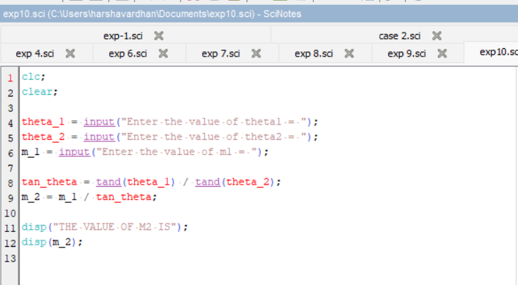

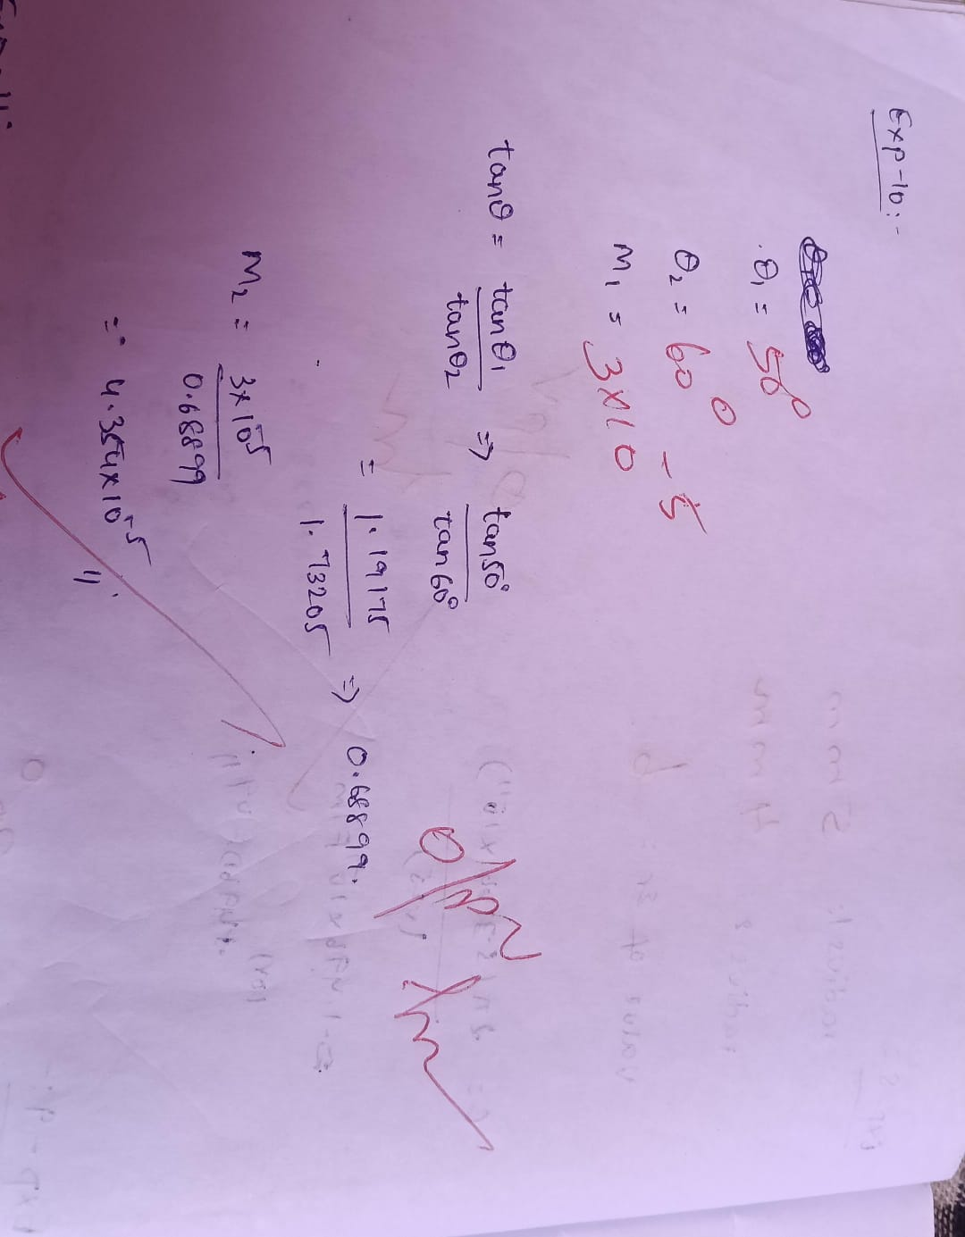
Calculation:

Output:

Case1:Considertwoidenticalmediainthepresenceofamagneticfield.Therelative permeabilityinbothmediais1.Whatwillbetheeffectofthisonthemagneticfieldand flux density across the boundary?
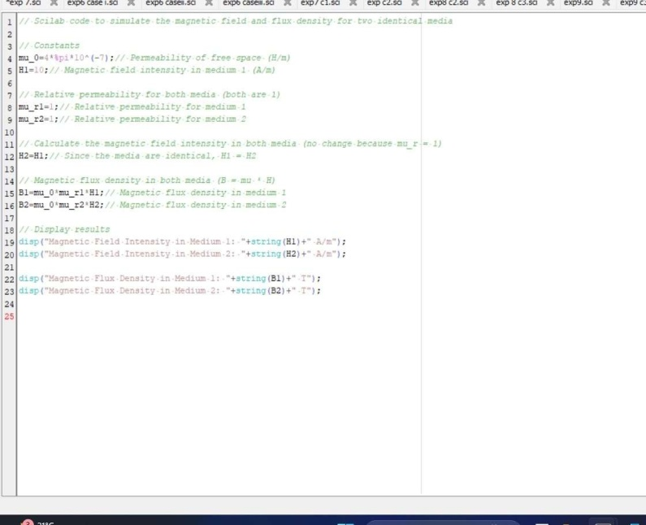
Output:

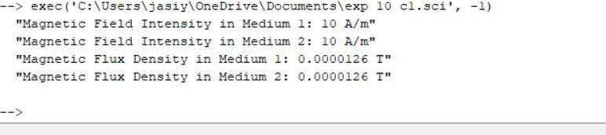
Case2:Inasystemwithtwomedia,wheretherelativepermeabilityofmedium1is μr1=4andmedium2isavacuum(μr2=1),howwouldthemagneticfieldintensityand flux density behave at the boundary?
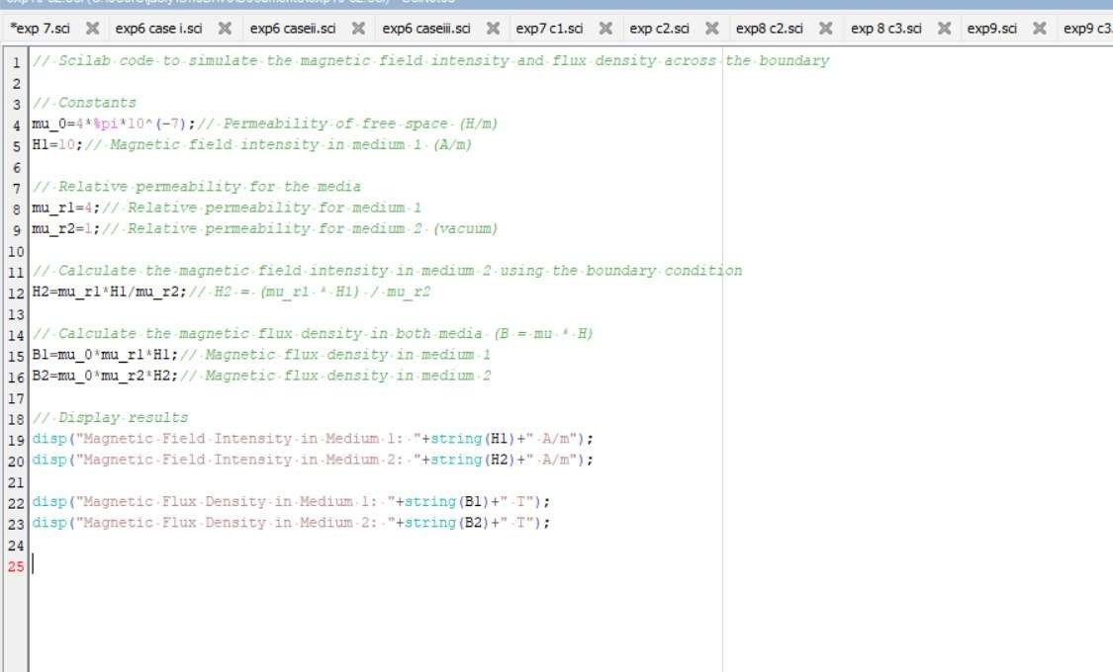
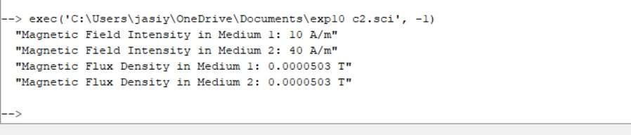

Case3:Ifmedium1hasarelativepermeabilityμr1=0.3andmedium2hasarelative permeabilityμr2=2,calculatethemagneticfieldintensityinbothmediaattheboundary ifthemagneticfieldintensityinmedium1isknowntobeH1=10A/m.

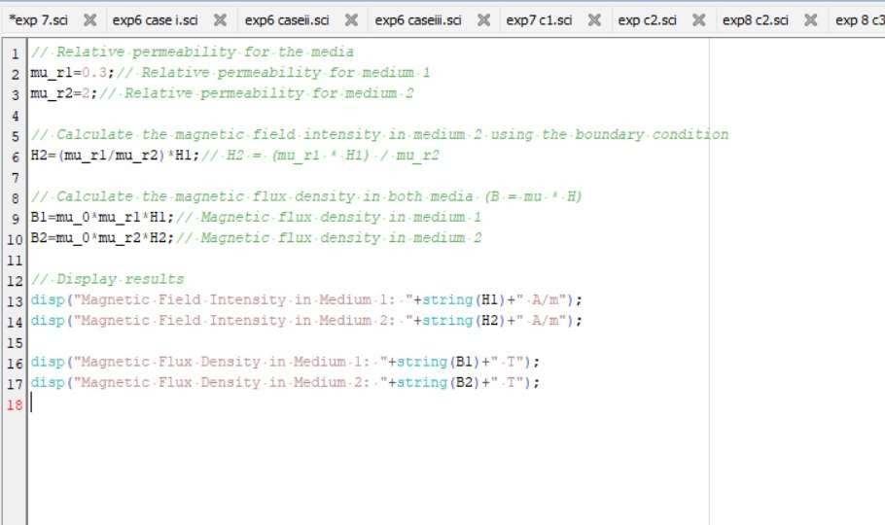
Output:
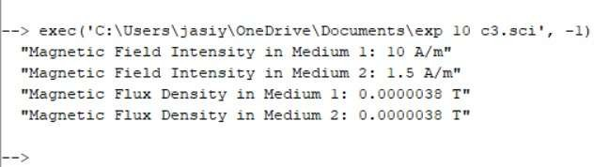

Result:Thustheeffectoftwodifferentmediaonthemagneticfieldandfluxdensity across the boundary is calculated.ssd

